Output:

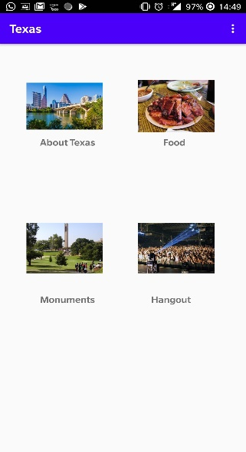 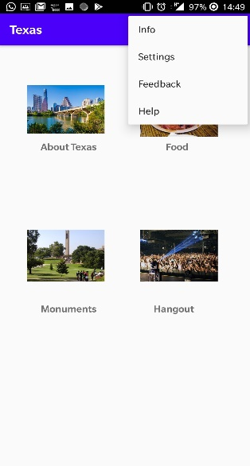 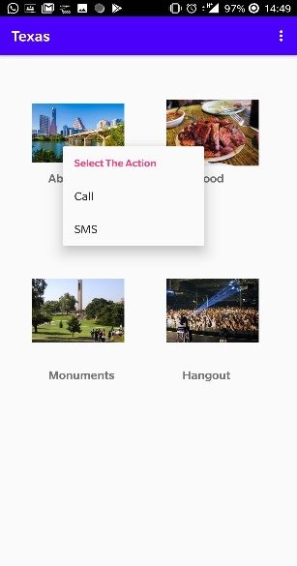 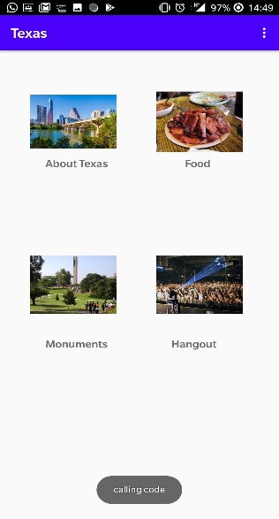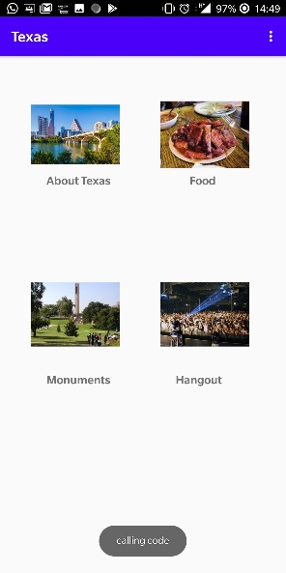

Java code:

package com.example.jonathanacharya.texas;  
  
import android.content.Intent;  
import android.support.v4.app.ActivityOptionsCompat;  
import android.support.v4.view.ViewCompat;  
import android.support.v7.app.AppCompatActivity;  
import android.os.Bundle;  
import android.view.ContextMenu;  
import android.view.Menu;  
import android.view.MenuInflater;  
import android.view.MenuItem;  
import android.view.View;  
import android.widget.ImageView;  
import android.widget.Toast;  
  
public class MainActivity extends AppCompatActivity {  
ImageView i1,i2,i3,i4;  
 @Override  
 protected void onCreate(Bundle savedInstanceState) {  
 super.onCreate(savedInstanceState);  
 setContentView(R.layout.*activity_main*);  
 i1=findViewById(R.id.*image*);  
 i1.setOnClickListener(new View.OnClickListener() {  
 @Override  
 public void onClick(View v) {  
 Intent intent = new Intent(MainActivity.this, NewAcitivity.class);  
 ActivityOptionsCompat options = ActivityOptionsCompat.*makeSceneTransitionAnimation*(MainActivity.this,i1, "simple_activity_transition");  
 startActivity(intent, options.toBundle());  
 }  
 });  
 i2=findViewById(R.id.*image1*);  
 i2.setOnClickListener(new View.OnClickListener() {  
 @Override  
 public void onClick(View v) {  
 Intent intent = new Intent(MainActivity.this, NewActivity2.class);  
 ActivityOptionsCompat options = ActivityOptionsCompat.*makeSceneTransitionAnimation*(MainActivity.this,i2, "simple_activity_transition");  
 startActivity(intent, options.toBundle());  
 }  
 });  
 i3=findViewById(R.id.*image2*);  
 i3.setOnClickListener(new View.OnClickListener() {  
 @Override  
 public void onClick(View v) {  
 Intent intent = new Intent(MainActivity.this, NewActivity3.class);  
 ActivityOptionsCompat options = ActivityOptionsCompat.*makeSceneTransitionAnimation*(MainActivity.this,i3, "simple_activity_transition");  
 startActivity(intent, options.toBundle());  
 }  
 });  
 i4=findViewById(R.id.*image3*);  
 i4.setOnClickListener(new View.OnClickListener() {  
 @Override  
 public void onClick(View v) {  
 Intent intent = new Intent(MainActivity.this, NewAcitivity4.class);  
 ActivityOptionsCompat options = ActivityOptionsCompat.*makeSceneTransitionAnimation*(MainActivity.this,i4, "simple_activity_transition");  
 startActivity(intent, options.toBundle());  
 }  
 });  
  
 i1=(ImageView)findViewById(R.id.*image*);  
 i2=(ImageView)findViewById(R.id.*image1*);  
 i3=(ImageView)findViewById(R.id.*image2*);  
 i4=(ImageView)findViewById(R.id.*image3*);  
 registerForContextMenu(i1);  
 registerForContextMenu(i2);  
 registerForContextMenu(i3);  
 registerForContextMenu(i4);  
 }  
  
 @Override  
 public void onCreateContextMenu(ContextMenu menu, View v, ContextMenu.ContextMenuInfo menuInfo)  
 {  
 super.onCreateContextMenu(menu, v, menuInfo);  
 MenuInflater inflater = getMenuInflater();  
 inflater.inflate(R.menu.*main_menu*, menu);  
 menu.setHeaderTitle("Select The Action");  
 }  
 @Override  
 public boolean onContextItemSelected(MenuItem item){  
 if(item.getItemId()==R.id.*call*){  
 Toast.*makeText*(getApplicationContext(),"calling code",Toast.*LENGTH_LONG*).show();  
 }  
 else if(item.getItemId()==R.id.*sms*){  
 Toast.*makeText*(getApplicationContext(),"sending sms code", Toast.*LENGTH_LONG*).show();  
 }else{  
 return false;  
 }  
 return true;  
 }  
  
 @Override  
 public boolean onCreateOptionsMenu(Menu menu) {  
 // Inflate the menu; this adds items to the action bar if it is present.  
 getMenuInflater().inflate(R.menu.*context_layout*, menu);  
 return true;  
 }  
  
 @Override  
 public boolean onOptionsItemSelected(MenuItem item) {  
 int id = item.getItemId();  
 if (id == R.id.*Info*)  
 {  
 Toast.*makeText*(getApplicationContext(),"Information provided", Toast.*LENGTH_LONG*).show();  
 }  
 else if(id == R.id.*setting*)  
 {  
 Toast.*makeText*(getApplicationContext(),"Settings is on!", Toast.*LENGTH_LONG*).show();  
 }  
 else if(id == R.id.*feedback*)  
 {  
 Toast.*makeText*(getApplicationContext(),"Give Feedback", Toast.*LENGTH_LONG*).show();  
 }  
 else if(id == R.id.*help*)  
 {  
 Toast.*makeText*(getApplicationContext(),"Help needed?", Toast.*LENGTH_LONG*).show();  
 }  
 return super.onOptionsItemSelected(item);  
 }  
  
  
}

Xml code:

<?xml version="1.0" encoding="utf-8"?>  
<RelativeLayout xmlns:android="http://schemas.android.com/apk/res/android"  
 xmlns:app="http://schemas.android.com/apk/res-auto"  
 xmlns:tools="http://schemas.android.com/tools"  
 android:layout_width="match_parent"  
 android:layout_height="match_parent"  
 tools:context=".MainActivity">  
  
 <ImageView  
 android:id="@+id/image"  
 android:layout_width="128dp"  
 android:layout_height="96dp"  
 android:layout_alignParentLeft="true"  
 android:layout_alignTop="@+id/image1"  
 android:layout_marginLeft="44dp"  
 android:src="@drawable/image"  
 android:transitionName="simple_activity_transition"  
 tools:ignore="UnusedAttribute" />  
 <ImageView  
 android:id="@+id/image1"  
 android:layout_width="128dp"  
 android:layout_height="96dp"  
 android:layout_alignParentRight="true"  
 android:layout_alignParentTop="true"  
 android:layout_marginRight="53dp"  
 android:layout_marginTop="65dp"  
 android:src="@drawable/image1"  
 android:transitionName="simple_activity_transition"  
 tools:ignore="UnusedAttribute" />  
  
 <ImageView  
 android:id="@+id/image2"  
 android:layout_width="128dp"  
 android:layout_height="96dp"  
 android:layout_alignLeft="@+id/image"  
 android:layout_centerVertical="true"  
 android:src="@drawable/image2"  
 android:transitionName="simple_activity_transition"  
 tools:ignore="UnusedAttribute" />  
  
 <ImageView  
 android:id="@+id/image3"  
 android:layout_width="128dp"  
 android:layout_height="96dp"  
 android:layout_alignRight="@+id/image1"  
 android:layout_centerVertical="true"  
 android:src="@drawable/image3"  
 android:transitionName="simple_activity_transition"  
 tools:ignore="UnusedAttribute" />  
  
  
 <TextView  
 android:id="@+id/textView"  
 android:layout_width="wrap_content"  
 android:layout_height="wrap_content"  
 android:layout_alignParentLeft="true"  
 android:layout_alignParentTop="true"  
 android:layout_marginLeft="67dp"  
 android:layout_marginTop="168dp"  
 android:textStyle="bold"  
 android:textSize="16dp"  
 android:text="About Texas" />  
  
 <TextView  
 android:id="@+id/textView2"  
 android:layout_width="wrap_content"  
 android:layout_height="wrap_content"  
 android:layout_alignParentRight="true"  
 android:layout_alignTop="@+id/textView"  
 android:layout_marginRight="101dp"  
 android:textStyle="bold"  
 android:textSize="16dp"  
 android:text="Food" />  
  
 <TextView  
 android:id="@+id/textView3"  
 android:layout_width="wrap_content"  
 android:layout_height="wrap_content"  
 android:layout_alignParentBottom="true"  
 android:layout_alignStart="@+id/textView"  
 android:layout_marginBottom="267dp"  
 android:text="Monuments"  
 android:textSize="16dp"  
 android:textStyle="bold" />  
  
 <TextView  
 android:id="@+id/textView4"  
 android:layout_width="wrap_content"  
 android:layout_height="wrap_content"  
 android:layout_alignParentRight="true"  
 android:layout_alignTop="@+id/textView3"  
 android:layout_marginRight="92dp"  
 android:textStyle="bold"  
 android:textSize="16dp"  
 android:text="Hangout" />  
  
  
</RelativeLayout>

Context_layout

<menu xmlns:android="http://schemas.android.com/apk/res/android"  
 xmlns:app="http://schemas.android.com/apk/res-auto"  
 xmlns:tools="http://schemas.android.com/tools"  
 tools:context="com.example.pavan.trial2.MainActivity">  
 <item  
 android:id="@+id/Info"  
 android:title="Info"  
 app:showAsAction="withText" />  
 <item  
 android:id="@+id/setting"  
 android:title="Settings"  
 app:showAsAction="withText" />  
 <item  
 android:id="@+id/feedback"  
 android:title="Feedback"  
 app:showAsAction="withText" />  
 <item  
 android:id="@+id/help"  
 android:title="Help"  
 app:showAsAction="withText" />  
</menu>

Main_menu:

<?xml version="1.0" encoding="utf-8"?>  
<menu xmlns:android="http://schemas.android.com/apk/res/android"  
 android:layout_height="wrap_content"  
 android:layout_width="wrap_content">  
 <item android:id="@+id/call"  
 android:title="Call" />  
 <item android:id="@+id/sms"  
 android:title="SMS" />  
</menu>